Pathogen Cleanse
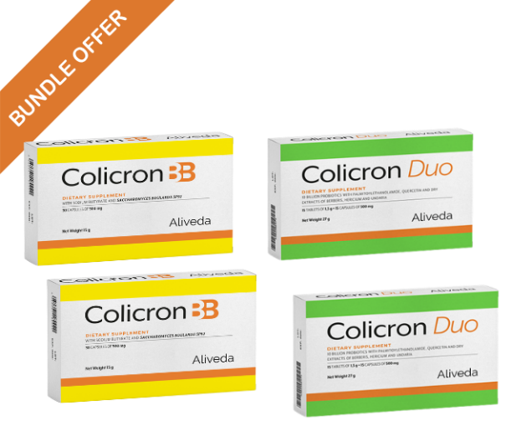
For the following conditions, combine Colicron Duo and Colicron BB, start a 30-day program (2 boxes of each), and repeat if necessary. On completion, maintain with Colicron at 1 per day.
Pathogen Cleanse Program AM. 1 Colicron Duo Tablet 1 Colicron BB Capsule. PM. 1 Colicron Duo Capsule 1 Colicron BB Capsule
Colicron Duo - Is unique in that each box contains 15 tablets and 15 capsules.
Each tablet contains Berberine and Quercetin
Offering broad-spectrum antimicrobial activity against various pathogens, including
bacteria, fungi, and parasites. Inhibiting the harmful species, while at the same time being
selective and promoting the growth of beneficial bacteria in the microbiome.
Both Berberine and Quercetin support the integrity of the intestinal barrier by enhancing tight junction proteins, thus reducing intestinal permeability (leaky gut).
Both reduce inflammation in the gut.

Each Capsule contains Lactobacillus Rhamnosus GG (LGG), PEA, Undaria and Hericium.
LGG is the most studied probiotic in history. It thrives on the sugars from fruits and vegetables and outcompetes the pathogens within our gut. The other 3 ingredients: PEA, Undaria, and Hericium, offer the following benefits…
- Act as Pre and Probiotics
- Are anti-inflammatory
- Improve gut permeability
- Help prevent diarrhea
- Act as an analgesic
- Repair gut lining and tissue
- Regulates intestinal transit

Colicron BB & Small Intestinal Bacterial Overgrowth (SIBO) - SIBO is characterized by an abnormal increase in the number of bacteria in the small intestine. Normally, the small intestine has a relatively low bacterial population compared to the colon. Colicron BB containing both Butyrate and Saccharomyces Boulardii is beneficial in managing SIBO by supporting gut health, restoring the microbial balance, and alleviating symptoms associated with the condition, such as diarrhea and enhancing gut motility.
Colicron BB & Candida - A crucial function of butyrate is preventing the shift of Candida from its harmless commensal yeast form into its invasive, pathogenic filamentous form. This is vital for controlling overgrowth. Butyrate enhances the body's natural immune response by increasing the activity and killing power of macrophages against pathogenic yeasts.
Both butyrate and S. Boulardii reinforce the intestinal barrier (via tight junction proteins), which helps prevent Candida from translocating beyond the gut into the bloodstream.
S. Boulardii secretes beneficial substances like capric acid and acetic acid, which have direct antifungal effects against Candida species
S. Boulardii actively inhibits the ability of Candida to form filaments (hyphae) and biofilms, the forms typically associated with infection and adhesion to gut walls.
As a non-colonizing yeast, S. Boulardii binds to Candida-associated toxins within the GI tract and facilitates their removal via stools, reducing the systemic impact of "die-off" reactions.
Colicron BB & Clostridioides difficile infection (CDI) - Butyrate, a short-chain fatty acid (SCFA) produced by beneficial gut bacteria, is often significantly reduced in patients with CDI-induced dysbiosis.
S. Boulardii releases a 54-kDa serine protease that can directly hydrolyze C. difficile toxins A and B, as well as their brush border membrane receptors in the human colon. This action reduces toxin binding and cellular damage.
Both S. Boulardii and Sodium Butyrate exhibit potent anti-inflammatory effects by suppressing pro-inflammatory mediators and regulating the balance of immune cells by reducing colon inflammation and diarrhea.
S. Boulardii and Butyrate support the intestinal barrier. S Boulardii helps maintain intestinal barrier integrity and reduces intestinal permeability. Butyrate is the primary energy source for colonocytes and promotes the integrity and maintenance of the epithelial barrier by increasing the expression of tight junction proteins (e.g., Claudin-1, Occludin) and strengthening the mucus layer.
Butyrate interacts with Farnesoid X Receptor [FXR} a bile acid sensor. Butyrate’s communication with FXR controls bile acid levels, inflammation, and metabolic pathways, including Butyrate stimulated hormones such as GLP1. This relationship is key as Butyrate promotes the production of secondary bile acids (which inhibit C. difficile growth) and reduces primary bile acids (which promote spore germination). Finally, FXR is involved in antibacterial defense and barrier function.
S. Boulardii and Butyrate both support Immune modulation, including the production of anti-toxin A immunoglobulin A [IgA] antibodies, which clear pathogens and toxins from the intestinal tract, and both ingredients support the microbiome, which is typically severely disrupted at this point.
Together, Colicron Duo and Colicron BB offer a very effective and extremely simple program, no more than 2 capsules twice per day, to improve the patient's gut health, remove pathogens, and impact the patient's quality of life.
For stubborn cases, consider adding Bio-Film Detox from Doctors’ Research and repeat the program if necessary.
Order at www.alivedalabs.com for the Practitioner offer price of $90.00

